**Lesson 7 – Assignment Hung Le**

**Chap 12 – Programming Assignment**

**Question 1:**

function extractGivenName(fullName){

let arr_tempt = fullName.split(",");

console.log(arr_tempt[0]);

}

let fullName ="Hung, Le";

extractGivenName(fullName);

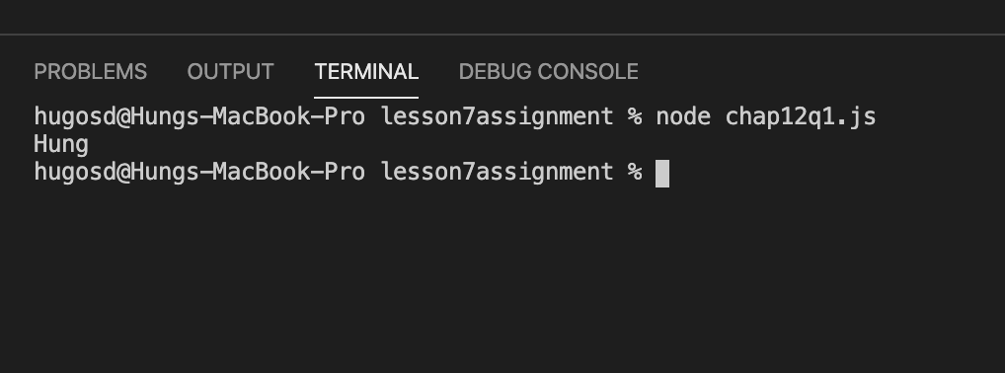

**Question 2:**

function prefix(string1, string2) {

let commonPrefix = [];

let arr1 = [];

let arr2 = [];

for (let i = 0; i < string1.length; i++) {

arr1[i] = string1[i];

}

for (let i = 0; i < string2.length; i++) {

arr2[i] = string2[i];

}

for (let i = 0; i < arr1.length; i++) {

if (arr1[i] === arr2[i]) {

commonPrefix[i] = arr1[i];

} else if(arr1[i] !== arr2[i]) break;

}

commonPrefix = commonPrefix.join();

commonPrefix = commonPrefix.replace(/,/g, "");

return commonPrefix;

}

let string1 = "disable";

let string2 = "distasteful";

let new_string = prefix(string1, string2);

console.log(new_string);

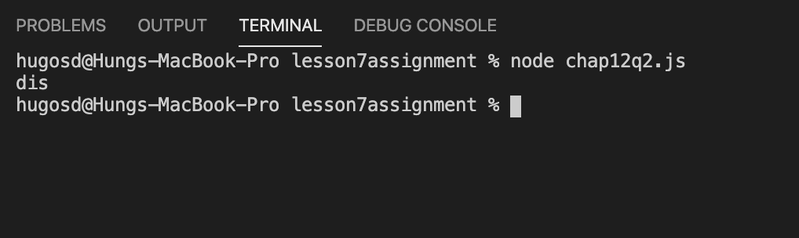

**Question 3:**

function suffix(string1, string2) {

let commonSuffix = [];

let arr1 = [];

let arr2 = [];

for (let i = 0; i < string1.length; i++) {

arr1[i] = string1[i];

}

for (let i = 0; i < string2.length; i++) {

arr2[i] = string2[i];

}

arr1 = arr1.reverse();

arr2 = arr2.reverse();

for (let i = 0; i < arr1.length; i++) {

if (arr1[i] === arr2[i]) {

commonSuffix[i] = arr1[i];

} else if(arr1[i] !== arr2[i]) break;

}

commonSuffix = commonSuffix.reverse();

commonSuffix = commonSuffix.join();

commonSuffix = commonSuffix.replace(/,/g, "");

return commonSuffix;

}

let string1 = "swimming";

let string2 = "walking";

let new_string = suffix(string1, string2);

console.log(new_string);

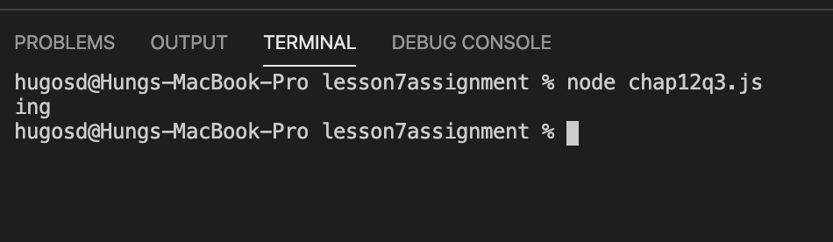

**Question 4:**

function switchCase(s) {

let s_tempt=[];

for (let i = 0; i < s.length; i++) {

if (s[i] !== s[i].toLowerCase()) {

s_tempt[i] = s[i].toLowerCase();

} else if (s[i] === s[i].toLowerCase()) {

s_tempt[i] = s[i].toUpperCase();

} else {

s_tempt[i] = s[i];

}

}

s_tempt = s_tempt.join();

s_tempt = s_tempt.replace(/,/g,"");

return s_tempt;

}

let s = "Catch 22";

new_s = switchCase(s);

console.log(new_s);

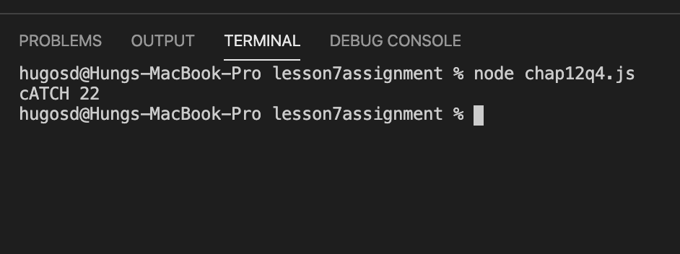

**Question 5:**

I have 2 solutions for this questions.

The first solution is very long. I convert string into arrays and the convert arrays back to string.

The second solution is very short. I use replace(/\w\S*/g, string) to look for all string value which are not blank spaces then use toUpperCase().

**Solution 1:**

function titleCase(s) {

let s_tempt = s.split(" ");

let firstLetter = "";

let arr_letter = [];

let counter = 0;

let s_output =" ";

for (let n of s_tempt) {

firstLetter = n[0];

firstLetter = firstLetter.toUpperCase();

for (let i = 1; i < n.length; i++) {

firstLetter += n[i];

}

arr_letter[counter] = firstLetter;

counter++;

}

s_output = s_output + arr_letter;

s_output = s_output.trim();

s_output = s_output.replace(/,/g, " ");

return s_output;

}

let s = "we are the world!";

let new_s = titleCase(s);

console.log(new_s);

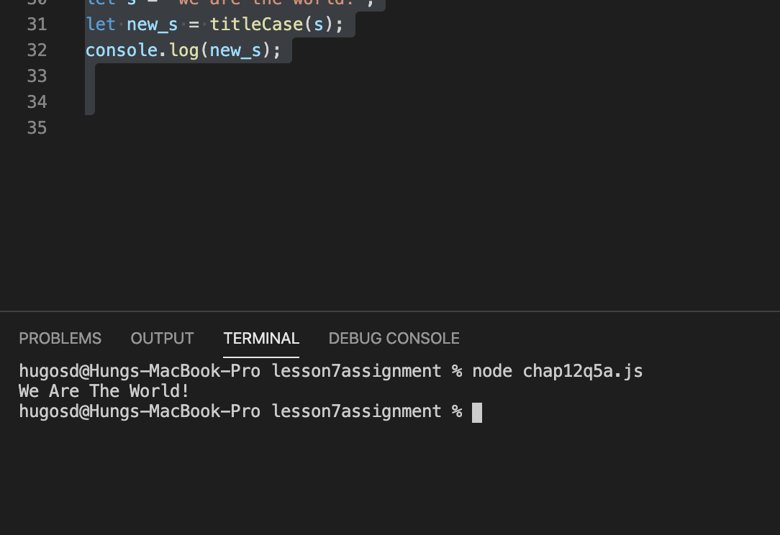

**Solution 2:**

function titleCase(s) {

let firstLetter = function (s) { return s[0].toUpperCase() + s.substr(1).toLowerCase() }

let s_output = s.replace(/\w\S*/g, firstLetter);

return s_output;

}

let s = "we are the world!";

let s_output = titleCase(s);

console.log(s_output);

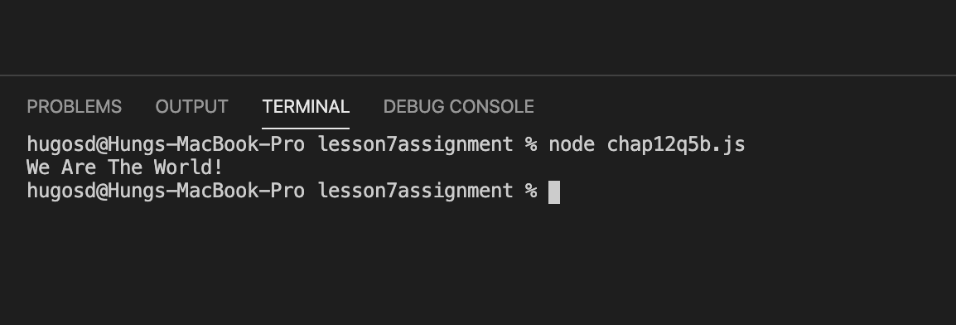

**Car Object**

let car = {

make: "Nissan",

model: "Sentra",

year: 2015,

odometer: 80000,

serviceCount: 20,

service: function () { return this.serviceCount++; },

getOdemeterReading: function () { console.log(this.odometer) },

reset: function(){ return this.serviceCount = this.odometer = 0},

showService: function () { console.log(this.serviceCount); },

showReset: function () { console.log(this.serviceCount); console.log(this.odometer);},

}

car.service();

car.service();

car.service();

car.showService();

car.getOdemeterReading();

car.reset();

car.showReset();

